Game design document (GDD)

*By: Mohammad Ibrahim Salman*

*ID: 101029175*

10/11/2024

**Table of content**

**Introduction**

**Wimbledon’s Lot** is a 2D adventure game that invites players into a richly atmospheric medieval world, where the strategic depth of exploration, interaction, and decision-making takes center stage. Inspired by Sid Meier's concept of “a series of interesting choices,” the game emphasizes thoughtful player decisions, complex problem-solving, and a narrative unfolding through exploration and meaningful character interactions. Rooted in the classic gameplay styles of 16-32 bit era titles like *Zelda* and *Monkey Island*, **Wimbledon’s Lot** combines nostalgic visuals with a compelling storyline, making it accessible and engaging for players of all ages.

In **Wimbledon’s Lot**, players assume the role of a knight-wizard hybrid navigating the eerie medieval town of Wimbledon. Set against a backdrop of lush grasslands and towering mountains, the town holds mysteries intertwined with its long history, much of which players will uncover through interactions with NPCs and the discovery of hidden items. The unfolding story, influenced by titles like *Twin Peaks*, *Salem’s Lot*, and *Firewatch*, offers players an experience steeped in suspense and intrigue. The game encourages players to follow subtle clues, solve puzzles, and explore new areas unlocked by found items, creating a gameplay experience that blends exploration with gradual, immersive storytelling.

The development of **Wimbledon’s Lot** is grounded in the use of the Godot engine, chosen for its open-source flexibility and robust support for 2D and 3D game development. Godot’s GDScript language, reminiscent of Python, allows for an accessible and intuitive coding experience, making it an ideal foundation for this project. By using Godot, this project leverages a sophisticated toolset to create a highly polished game that surpasses the limitations often encountered in simpler frameworks like Pygame.

A key objective in this project is to address the challenge of accidental complexity—complicated code resulting from rushed or ad-hoc design choices. To mitigate this, **Wimbledon’s Lot** will employ established design patterns as templates for common game mechanics, such as NPC interactions, inventory management, and combat systems. These patterns will not only streamline development but also enhance the game's scalability, making future updates and expansions more manageable. Additionally, all implemented patterns will be documented in the GAME-DP repository, offering practical guides and reusable templates to assist both novice and experienced developers. Drawing on examples from other games, including Unity projects, these resources will provide concrete guidance on implementing complex mechanics efficiently.

With exploration as a core focus, **Wimbledon’s Lot** encourages players to roam freely within its medieval setting, engage with NPCs for hints and clues, and battle creatures scattered across the land by a mysterious, unseen force. As players delve deeper into the story, they will encounter combat scenarios involving medieval weaponry—swords, bows, spears, and period-appropriate items like bombs—allowing for a blend of strategy and action that aligns with the game’s thematic era.

In summary, **Wimbledon’s Lot** aims to offer players a uniquely engaging experience where exploration, meaningful choices, and a mysterious storyline blend seamlessly. By integrating well-documented design patterns and leveraging Godot’s capabilities, the game promises not only to deliver an immersive experience for players but also to contribute valuable resources to the game development community.

**Game Overview**

* **Game Title**: Wimbledon’s Lot  
  **Genre**: Adventure / Exploration / Action  
  **Platform**: PC  
  **Target Audience**: All ages

**Core Concept**:

*Wimbledon’s Lot* is a top-down, 2D adventure that blends the exploration and action-driven mechanics of *The Legend of Zelda: A Link to the Past* with the rich storytelling and character interaction of *Monkey Island* and *Grim Fandango*. Set in the medieval town of Wimbledon’s Lot, a place nestled amidst sprawling grasslands and encircled by mountains, players take on the role of a hybrid knight-wizard tasked with unravelling the mysteries that lurk beneath the town’s quaint surface. Players will uncover secrets, collect items that unlock new areas, and piece together the town’s enigmatic history.

**Game Mechanics**:

* **Exploration and Combat**: The game’s top-down perspective allows for fluid movement and exploration of diverse environments, from grassy fields and mountainous terrain to intricate dungeons. Combat, inspired by classic 16-32-bit adventure games, involves swords, bows, spears, and items like bombs, adding strategic variety to battles with enemies scattered throughout the town by a mysterious, unseen force.
* **Dungeons and Quests**: Players will encounter dungeons filled with enemies, puzzles, and traps, each holding an essential item that propels the storyline forward. Completing quests, solving environmental puzzles, and finding treasure within chests and hidden locations are core to progression, offering rewards such as gold, essential items, and story-revealing artifacts.
* **Inventory and Objectives**: A simple yet effective inventory system lets players manage weapons, quest-related items, and collectables. The objectives panel keeps track of key goals and side quests, while the map feature helps players navigate the town and surrounding lands, highlighting areas of interest and locations yet to be explored.
* **Dialogue and Interaction**: Drawing from the dialogue-driven gameplay of *LucasArts* classics, *Wimbledon’s Lot* allows players to interact deeply with NPCs, accessing dialogue trees that advance the story and provide vital clues. Selecting specific responses may unlock new quests, reveal lore, or offer context for the items found, adding depth to player choices and rewarding attentive exploration.

**Collectables and Lore**:

Collectables, hidden in chests or tucked away in secret areas, provide insights into Wimbledon’s Lot’s lore, enhancing the backstory and revealing the town's hidden past. Some items might appear mundane at first, but with further exploration, they gain meaning, contributing to a deeper, layered storytelling experience.

**Visual and Art Style**:

*Wimbledon’s Lot* employs a 32-bit pixel art style reminiscent of the Super NES era, capturing the charm and detail of fourth-generation video games. The visual style is designed to be vibrant and inviting, with lighthearted touches that complement the adventure tone, striking a balance between mystery and approachability for a broad audience.

**Gameplay Theme**:

At its core, *Wimbledon’s Lot* embodies a lighthearted adventure where exploration and discovery take precedence. Players are encouraged to explore at their own pace, engage with characters, and piece together the story bit by bit. The gameplay encourages patience, curiosity, and strategic thinking as players work towards the satisfying reveal at the game’s end, where all the mysteries of Wimbledon’s Lot are fully unveiled.

**Gameplay**

**Progression and Unlockable Areas**:

*Wimbledon’s Lot* follows a structured yet flexible progression system, where certain areas are accessible only after meeting specific requirements. Players may need to complete a dungeon, defeat a powerful enemy, or fulfill an NPC’s quest before unlocking new locations. This approach blends *Zelda*-style dungeon progression with *Monkey Island*-inspired character-based quests, encouraging players to interact with the environment and NPCs to move forward.

**Gold and Upgrades**:

Gold serves as the primary in-game currency, enabling players to buy essential upgrades and items that enhance their abilities. Gold can be spent to:

* Acquire extra health (increasing heart count)
* Unlock new abilities like a spinning attack, sword charge, or temporary armor and shields
* Purchase consumables such as extra arrows and bombs
* Access certain levels or buy critical information from NPCs that may unlock quests or provide hints This progression system incentivizes exploration and reward collection, allowing players to strengthen their character in both combat and defense as they delve deeper into the game.

**Combat and Inventory System**:

Combat is straightforward, utilizing weapons and items like swords, arrows, bombs, and shields. The player’s inventory, accessible through a paused menu, allows them to equip various loot items based on the challenges they face. Combat includes light platforming mechanics, requiring players to dodge enemy projectiles and time their attacks effectively. Players may use their newly acquired skills and gear to overcome increasingly challenging enemies, which appear in specific areas throughout Wimbledon’s Lot.

**Checkpoints and Respawns**:

The game features strategically placed checkpoints, allowing players to respawn close to the area where they were defeated. This ensures smoother progression without the need to retrace large areas, making gameplay more forgiving while still maintaining a sense of challenge.

**Camera and Controls**:

The camera follows the player automatically, providing an intuitive and fluid experience without requiring manual camera adjustments. This design choice keeps the gameplay experience focused on exploration, combat, and puzzle-solving, seamlessly adapting to each area as the player moves through the town and beyond.

**Narrative Journals and Quest Hints**:

Hidden journals scattered throughout Wimbledon’s Lot serve as collectible items stored in the player’s inventory. These journals add depth to the story, providing insights into the town’s past, its mysteries, and hints for current quests or puzzles. Players can access these entries at any time, allowing them to revisit valuable information that may aid in their journey or provide crucial context for unfolding events.

**Objective and Final Confrontation**:

The game’s overarching objective is to explore Wimbledon’s Lot, assist its characters, and uncover the truth behind the town’s mysteries. As players gather key items, complete quests, and strengthen their character, they will ultimately confront the primary antagonist in an epic final boss fight. This climactic battle reveals the true nature of the villain and brings the story to a satisfying close, wrapping up the player's journey through Wimbledon’s Lot.

**Story and Narrative**

In *Wimbledon’s Lot*, players step into the boots of St. Dufresne, a knight with a secret mission. Sent by a wealthy merchant under the pretence of securing an estate, Dufresne's true purpose is far graver: to investigate the shadowy mysteries that haunt the town and to seek out the elusive figure known only as "The Man of the Black Lodge." As he delves deeper into the eerie streets, he uncovers unsettling tales and strange omens, gathering relics, hidden artefacts, and long-lost journals that weave together the town’s sinister past. Each quest brings him closer to the Black Lodge, a hidden stronghold shrouded in darkness and whispered legends. But the truth he discovers is more dangerous than he imagined—the Man of the Black Lodge harbours ambitions to create a monolithic authoritarian empire, a ruthless one-world company destined to control all trade, extinguish economic freedom, and strangle the prosperity of every independent soul. With only his courage, wits, and a growing arsenal of powers, Dufresne must face this enemy of liberty in a final showdown, battling to preserve the last bastions of freedom and prosperity in a world threatened by oppression.

**Levels and Environments**

The world of ***Wimbledon’s Lot*** unfolds across a series of atmospheric levels and interconnected locations, each with its unique environment, challenges, and lore to uncover. From the eerie village streets to dark forests and haunted manors, each area presents distinct obstacles, enemies, and interactive opportunities that immerse players in the quest to reach the Black Lodge and confront the Man of the Black Lodge.

**Castle Rock and Town Exercitus (Central Hub):**

* **Setting:** The heart of Wimbledon’s Lot is Castle Rock, where villagers live and go about their daily routines. Town Exercitus, the larger commercial district, is nearby and serves as the game’s central hub. These bustling medieval areas are filled with shops, markets, and NPCs who provide quests, clues, and trade options.
* **Objectives:** Here, players gather information, buy and upgrade gear, and accept new quests that open pathways to the more dangerous levels. Castle Rock and Town Exercitus are relatively safe, allowing players to build up resources, hone their skills, and equip themselves for the challenges ahead.
* **Unique Features:** Various NPCs provide clues, sell items, and offer upgrades. Shorter pathways between shops and quest locations introduce mild enemies, like pesky bandits and mischievous animals, to prepare players for what lies ahead.

**Hughenden Forest (Level 1):**

* **Setting**: Hughenden Forest is a dense, dark woodland teeming with hostile creatures and supernatural dangers. Its twisted trees and foggy paths make navigation challenging, while the ominous sounds hint at lurking threats. Shadows shift and trees seem to move, creating a haunting sense of being watched.
* **Objectives**: In this level, players must find and collect enchanted items scattered throughout the forest, needed to unlock the path to the next location. Quests may involve rescuing lost villagers, finding relics, and collecting gold.
* **Unique Feature:**
* **Enemies**: Wild animals and demonic entities roam freely. Wolves, venomous snakes, and shadowy creatures increase in number as players venture deeper into the forest
* **Environmental Hazards**: Thick mist reduces visibility, and certain parts of the forest are cursed, sapping the player’s health if they linger too long. Fallen trees, thorny bushes, and hidden pits obstruct paths, requiring players to be vigilant.
* **Puzzle Elements**: Ancient stones and hidden markings within the forest lead to powerful relics, but players must solve puzzles to access them.

**Gosford Cave (Level 2):**

* **Setting**: Gosford Cave is a dark, eerie network of caverns known as the “*cave of the living dead.*” Strange echoes fill the air as eerie apparitions drift through the caverns, blending with shadows cast by the player’s torch. The walls are lined with ancient carvings, hinting at a forbidden history.
* **Objectives:** Players must descend into the cave, searching for artefacts and clues related to the Man of the Black Lodge. This level includes both combat and puzzle-solving, as players navigate the maze-like caverns.
* **Unique Features:**
* **Enemies:** The cave houses undead soldiers, phantom apparitions, and invisible enemies that reveal themselves only when players use a particular enchanted item. Combat here is tense, as some enemies reanimate after being defeated.
* **Environmental Hazards:** Crumbling ledges, sudden drops, and narrow paths force players to tread carefully. Occasionally, cave-ins block paths, requiring players to find alternative routes or use explosives.
* **Puzzle Elements:** Players must use light and shadow to reveal hidden pathways and unearth secrets. Lever-based puzzles and pressure plates add complexity to navigation and require careful timing and precision.

**Shrieking Manor (Level 3):**

* **Setting:** Shrieking Manor is a sprawling, ancient mansion with creaking floors, endless corridors, and a sinister history. Despite its lavish appearance, the manor harbours a dark secret, including a hidden dungeon filled with monstrous creatures and cursed artefacts.
* **Objectives:** This level requires players to investigate the manor, locate the hidden dungeon, and retrieve a key artefact that unlocks the path to the Black Lodge. Along the way, players uncover hidden journal entries, offering glimpses into the Manor’s cursed history.
* **Unique Features:**
* **Enemies:** Ghostly inhabitants, restless spirits, and enchanted suits of Armor guard the halls. In the hidden dungeon, more dangerous foes await, such as soul-devouring wraiths and a mini-boss bound to protect the artefact.
* **Environmental Hazards:** The manor’s layout is a maze of shifting corridors, moving walls, and trap-laden floors. Hidden pressure plates and ghostly traps set off attacks from phantom hands, ghostly laughter, and misleading illusions that add to the unsettling atmosphere.
* **Puzzle Elements:** Certain rooms require players to solve logic puzzles to open doors, deactivate traps, or access hidden passages. Hints for these puzzles are often hidden within the mansion’s ancient paintings and dusty tomes.

**The Black Lodge (Final Level):**

* **Setting:** Once all quests and levels are complete, players receive a special key (*or are magically transported*) to the Black Lodge, a forested area unlike any other in Wimbledon’s Lot. This shadowy forest is filled with unnatural stillness and leads to a lone wooden cabin nestled among ominous trees. Inside, players find themselves in a surreal, distorted realm, a twisted lair with blood-red curtains, dim lighting, and unsettling patterns on the floor, walls, and furniture. The otherworldly atmosphere is disorienting, evoking an eerie sense of dread.
* **Objectives:** The objective here is simple yet perilous: confront and defeat the Man of the Black Lodge, the final antagonist of the game. Players must navigate this bizarre space and its surreal obstacles before facing the climactic battle that will determine the fate of Wimbledon’s Lot.
* **Unique Features:**
* **Enemies:** The Black Lodge itself seems alive, with shadowy apparitions, illusions, and distorted reflections that confuse players and make navigation disorienting. The final encounter pits players against the Man of the Black Lodge, whose combat style includes dark magic, mind manipulation, and summoning illusions.
* **Environmental Hazards:** In this twisted environment, rooms loop back on themselves, doors lead to random areas, and sudden hallucinations create obstacles. The entire space is a psychological challenge, disorienting the player as they search for the true path to the Man of the Black Lodge.
* **Final Battle:** The final battle with the Man of the Black Lodge tests all the skills players have gathered along the way. He employs a mix of illusions, powerful attacks, and summoned minions to overwhelm the player, requiring strategy and timing to defeat. The encounter concludes with a dramatic showdown, where the player must use all their weapons and abilities to seal the villain’s dark ambitions and free Wimbledon’s Lot from his grip.

Each location in ***Wimbledon’s Lot*** is intricately woven into a cohesive, interconnected world, inviting players to explore both familiar hubs and treacherous levels as they progress toward the final showdown. Before reaching the Black Lodge, players can freely roam the world, uncovering secrets and traversing the varied landscapes of **Castle Rock, Town Exercitus, Hughenden Forest, Gosford Cave, and Shrieking Manor**. These locations are not isolated; rather, they connect through winding trails, dense forests, and hazardous pathways populated by roaming enemies, forcing players to stay alert as they make their way between objectives.

At the center of this world lies the **Merchant’s Estate**, serving as the main hub where players can regroup, access upgrades, and receive guidance. The estate offers a welcome respite between quests, with the Merchant himself providing valuable tips, hints, and story insights that propel the narrative forward. While players can wander freely, one unique gameplay feature is the option to fast travel back to the **Merchant’s Estate**—an essential mechanic, as it allows players to quickly regroup, resupply, and prepare for the next adventure without needing to backtrack through the dangerous terrain.

This structure encourages players to explore every corner of ***Wimbledon’s Lot***, gathering items, upgrading abilities, and facing a range of enemies, from minor nuisances to formidable foes, who vary depending on the region. The carefully balanced mix of combat and exploration makes each journey back and forth engaging, as players constantly encounter new challenges, shifting obstacles, and subtle environmental clues that bring the world’s rich lore to life. By the time they reach the final level, players will have developed a deep understanding of both the game’s world and their own character’s skills, ready to face the unforgettable final confrontation in the Black Lodge.

**User Interface (UI) and Controls**

The user interface in *Wimbledon’s Lot* is designed to be intuitive and immersive, with three main components: the Start Menu, the Pause Menu, and the Inventory. Each part is tailored to provide players with streamlined access to essential gameplay options and information, ensuring a seamless experience that enhances the game’s overall atmosphere. *Examples are presented in pictures to present the idea of the UI.*

The **Start Menu** in *Wimbledon’s Lot* sets the tone with a haunting, playful background scene of the Merchant’s Estate, accompanied by atmospheric music that hints at the game’s mysterious storyline. The Start Menu offers three primary options: *Start*, *Options*, and *Exit*. Selecting *Start* opens a submenu where players can choose to either begin a new game or load a previously saved game from one of the four save slots provided. In *Options*, players can adjust settings for volume and sound effects or customize the PC keyboard control scheme to their preference. The *Exit* option closes the game and returns players to their desktop. This introductory menu creates a compelling and immersive entry into the game, setting players up for the adventure ahead.

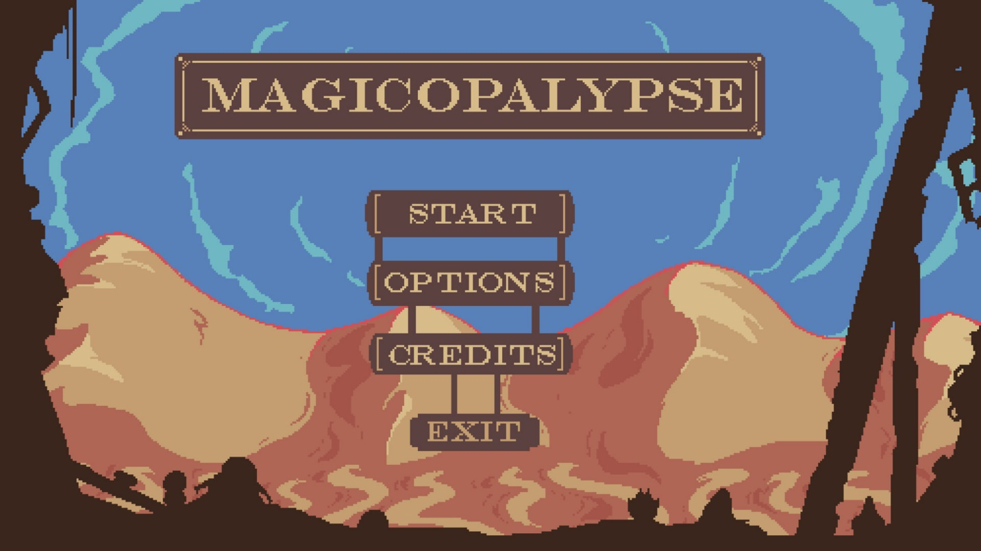

The **Pause Menu** can be accessed anytime during gameplay, providing players with a convenient in-game hub for managing their settings or checking their progress. This menu features three options: *Resume*, *Options*, and *Exit to Start Menu*. The *Resume* option allows players to immediately return to their game, while *Options* provides the same settings found in the Start Menu, such as volume and control adjustments. *Exit to Start Menu* returns players to the Start Menu, where they can load a different save or quit the game if desired. On the right side of the Pause Menu, a progress overview displays the player's completion percentage and a list of current objectives, helping players stay focused on their goals.

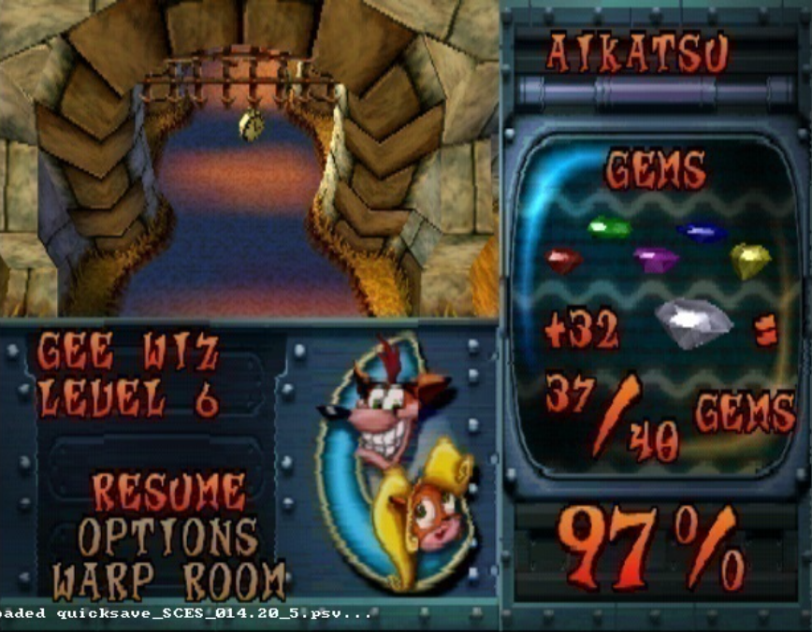

In the **Inventory Menu**, players can view and manage all the items, lore, and collectibles they’ve gathered on their journey. The Inventory is designed for easy navigation, with visuals and brief descriptions for each item, allowing players to quickly identify each item’s purpose and relevance to their quests. This menu includes sections for items, equipped gear, and collectibles. The *Gold Counter* at the top shows players their total gold, which can be used for upgrades, new abilities, and equipment purchases. An *Equipped Items* section displays items currently equipped for quick access in gameplay, while a separate area houses lore entries and collectibles that players have gathered throughout Wimbledon’s Lot, adding depth to the story and enriching the player’s understanding of the world. This menu provides players with a rich and organized hub, allowing them to immerse themselves in both gameplay essentials and the lore of the game’s universe.

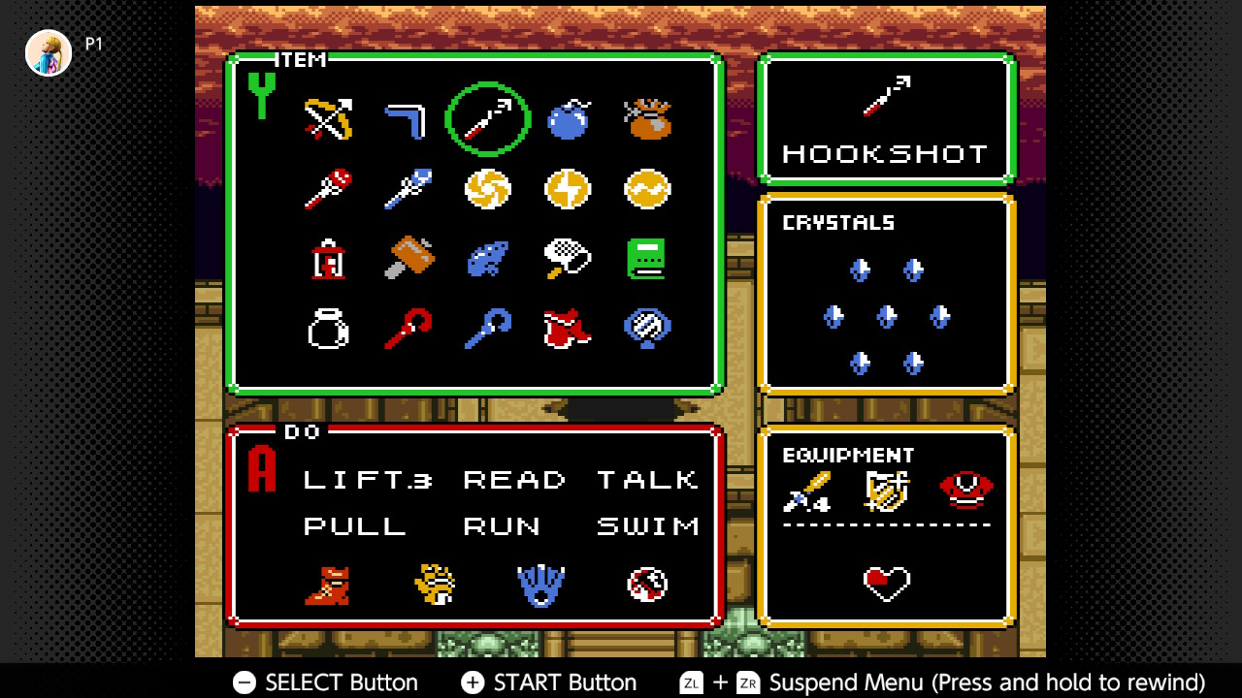

*Wimbledon’s Lot* supports both controller and keyboard setups, offering flexibility for players on different platforms. Here is an ideal control scheme for both controller and keyboard.

Keyboard default Controls

**Move:** Arrow keys or WASD

**Navigate Inventory:** Arrow keys or WASD within the inventory screen

**Talk/Interact:** E key

**Run:** Shift key (hold)

**Lift / Throw:** Spacebar

**Push / Pull:** F key

**Swing Sword:** Left mouse button

**View Map:** M key

**Use Item:** Q key

**Open Save Menu:** F5 key

**Open Inventory:** Tab key

Controller Scheme (Xbox)

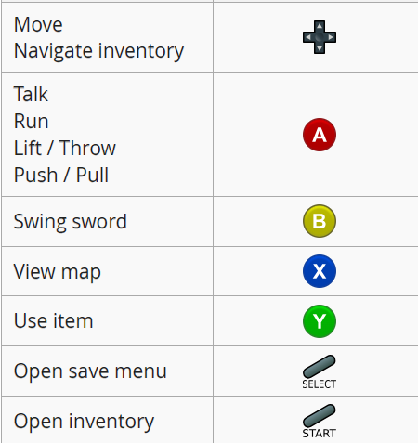

This control scheme emphasizes ease of movement, inventory management, and quick access to combat actions. The familiar setup allows players to transition smoothly from other games, while also providing options for customization to suit personal preferences.

In *Wimbledon’s Lot*, dialogue between characters appears in clean, readable text bubbles that overlay the scene, allowing for seamless interaction without breaking immersion. When the player speaks to a character, their words are displayed in a distinctive font, making it clear who's talking. The dialogue often includes branching options, where players can choose responses that influence the flow of conversation. These choices affect the information received, open new quests, or sometimes reveal hidden lore. The dialogue bubbles fade in and out with a subtle animation, creating a natural, conversational feel that makes each exchange with NPCs engaging and memorable.

